**DBAS 1007 – Assignment 3 – Multi-Table SELECT Queries and Aggregates   
Value:** 10% of your overall mark.

**Instructions:**Create a single script file that will contain SQL statements to perform the following requirements against the **Sakila** database. Read the instructions carefully to ensure that you understand the requirements for each query. If you do not understand a question, it is your responsibility to clarify the requirements with your instructor.  
Be sure to attempt all questions as you may be awarded partial marks for your work.  
When you are finished, submit your script file on BrightSpace as **[YourName]_DBAS_Assignment3.sql**.

**In your script, please remember to clearly label your solution statement for each question with a comment indicating for which question it is the solution. Example:**

**#Query 1**

**SELECT…**

**Query Requirements, using the Sakila database:**

1. Create a query that displays a list of Sakila stores (IDs) and the first/last name of each store's manager.
2. Create a query that displays a list of all cities and their associated countries, alphabetized by country.
3. Create a query that displays the names of every actor and the number of movies they are in. Display the actor's last and first names and sort from most movies to least. Rename columns as indicated.
4. Create a query that displays a list of all customers who currently reside in Japan. Show their last and first  
   names, city and country, sorted by city of residence, then by customer last name, first name.
5. Create a query that lists all G-rated movies in which actress Audrey Olivier has appeared. Display the actress' name in a single field named ActorName. Rename other columns as indicated.
6. Create a query that displays the total profits per staff member for rentals returned in July of 2005. Rename columns as indicated.
7. Create a query that displays which and how many movies are available for rental from store #1, that have an R rating, are 2 hours or less in run time, and that include deleted scenes as a special feature. Sort by movie length, from shortest to longest. Rename the Available column as indicated.
8. Create a query that displays the top five actors that have made the most rental profits for our store, sorted from largest profit to smallest. Rename columns as indicated.
9. Create a query that displays all movies from the Action or Comedy categories that were rented by Canadian customers, sorted by movie title. Display the name of the rented movie, its category, the customer's name as a single field and the country. Rename columns as indicated.
10. Create a query that displays how many movies were rented by customer Ruby Washington, listed by category. Display the customer's last and first names, the category and how many movies from each category were rented by this customer. Sort by category, then by customer last name. Rename columns as indicated.

**Screenshots of Expected Results**

**Query 1 (2 records)**

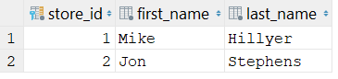

**Query 2 (500+ records, first 10 shown)**

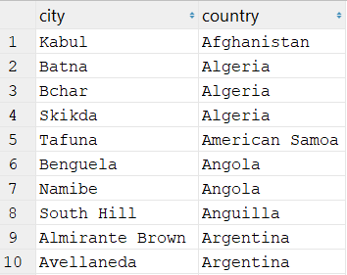

**Query 3 (199 records, first 10 shown)**

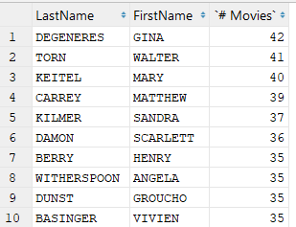

**Query 4 (31 records, first 10 shown)**

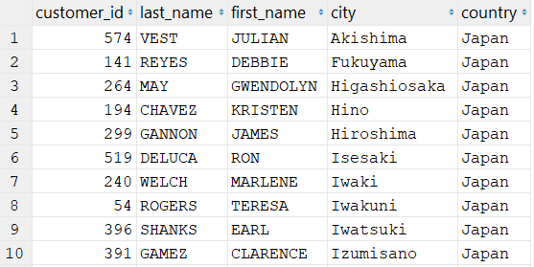

**Query 5 (5 records)**

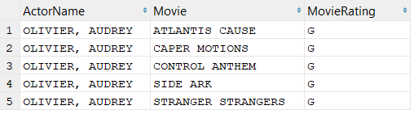

**Query 6 (2 records)**

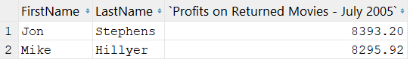

**Query 7 (43 records, first 10 shown)**

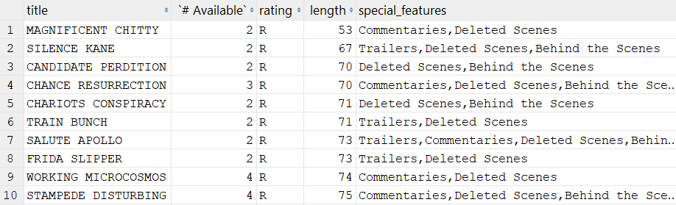

**Query 8 (5 records)**

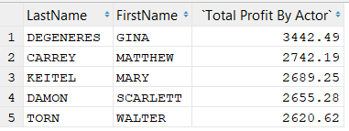

**Query 9 (16 records, first 10 shown)**

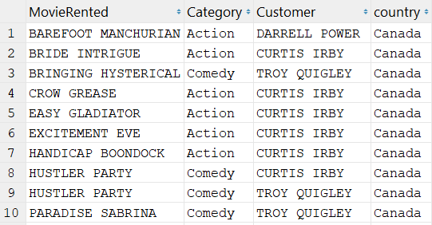

**Query 10 (12 records)**

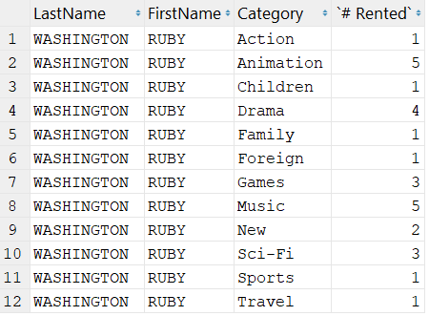

## Rubric

|  |  |  |
| --- | --- | --- |
| Questions 1-15 | **Yes _______ No _______ Partial _______** | 3 points each, 1-2 points for partial |
|  | **Total** | 30 points |